A results page where the score had been calculated and message will display at the bottom.

If the user answered wrongly, a message pop up says “You are Wrong!”.

If the user answered correctly, a message pop up says “You are Right!”.

A question from one of the topics from the ‘Learn Things’ page.

The ‘Learn Things’ page will have variety of topics to choose from.

This will have 4 modes of learning.

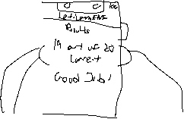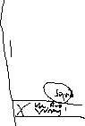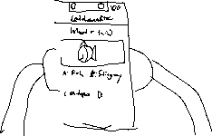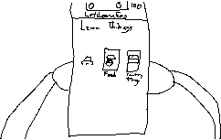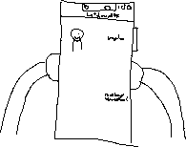

**Title:** Create storyboards to design UX/UI of the application

**Objective(s):**

In this lab, students will learn to design storyboard to

* visualise navigation wireframe in UX design and
* visualise app layout in UI design

**Tools, Equipment and Materials:**

1. [Hardware: Personal Computer with Internet access]
2. [Drawing Software: Photoshop]

**Instructions:**

**Part (A) – Use storyboard to visualise navigation wireframe in UX design**

1. Continue from Lab5A, draft a scenario to describe how the user can complete a task using the language learning app. (Refer to chapter 5 slide 24)
2. Choose the type of wireframe layout structure. (Refer to chapter 5 slide 19)
3. Use wireframe layout to plan the flow of application navigation. (Refer to chapter 5 slides 20-23, 26, 32)
4. Test the storyboard against the scenario.

**Part (B) – Use storyboard to visualise app layout in UI design**

1. Sketch a draft interface of the app according to user requirements and UX design. (Refer to chapter 5 slide 34)
2. Design the final UI use graphic design software such as Photoshop. (Refer to chapter 5 slides 35-37)

- End -